Smart Retail Checkout: Decision Logic, Evaluation Mindsets,
and Bias–Variance Tradeoffs in Java Programming

Abstract
This paper reflects on the design and implementation of the SmartRetailCheckout Java program, a checkout calculator that applies tiered discount logic, compound Boolean conditions, a switch-based tax system, and a risk-flagging mechanism. Through the implementation of thirteen structured tasks, key insights emerged regarding operator precedence, input validation, and the tradeoffs between simple and complex decision rules. The discussion connects programming logic to broader evaluation mindsets, including the bias–variance tradeoff concept, and proposes reliability improvements such as refactoring, unit testing, and logging. The program demonstrates that layered compound conditions yield fairer and more accurate outcomes than any single rule in isolation.

Keywords: decision logic, operator precedence, Java, bias–variance tradeoff, evaluation mindset.

Smart Retail Checkout: Decision Logic, Evaluation Mindsets,
and Bias–Variance Tradeoffs in Java Programming
The SmartRetailCheckout activity required implementing a complete checkout calculator in Java integrating input validation, tiered discounts, member bonuses, coupon rules, category-based taxation, and a multi-condition risk flag. Each component demanded careful application of decision-making constructs including if/else ladders, compound Boolean expressions, the switch statement, and the conditional operator (?:). This paper discusses key insights, a logic bug encountered and fixed, which rules produced the best outcomes, and connections to evaluation mindsets.
How Different Rules Affect Outcomes and Fairness
The program’s discount system illustrates how layering rules can improve or distort fairness. The base discount tier rewards bulk purchasing using a nested if/else ladder (TODO 7). Quantities of five or more receive 3%, ten or more receive 7%, and twenty or more receive 12%.
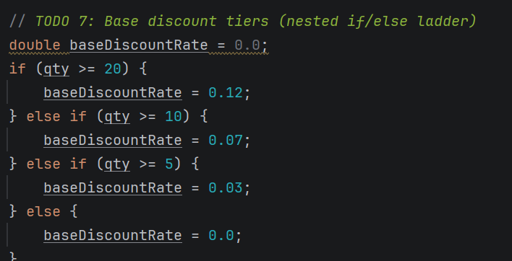
Figure 1. Tiered base discount if/else ladder (TODO 7).

The member bonus (TODO 8) uses a compound AND condition: the customer must be a member and have a subtotal of at least $200 to receive the additional 5% discount. This is fairer than a flat member discount because it ties the benefit to actual spending.
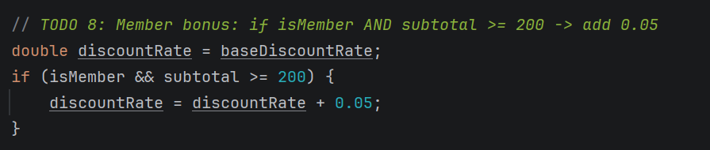
Figure 2. Member bonus using compound AND condition (TODO 8).

The SAVE10 coupon rule (TODO 10) uses both AND and NOT: the coupon applies only when the item is not on clearance. Math.max(0, ...) enforces a $0 floor, preventing negative totals.
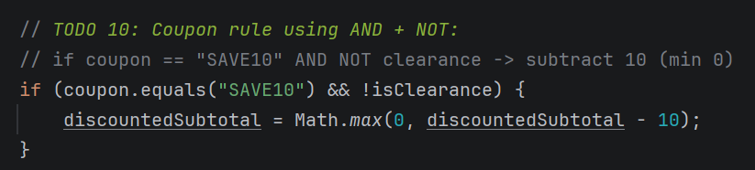
Figure 3. Coupon rule with AND and NOT operators (TODO 10).

The category tax switch (TODO 11) maps each product category to a statutory tax rate, reflecting real-world retail tax structures. A default case handles unrecognized categories.
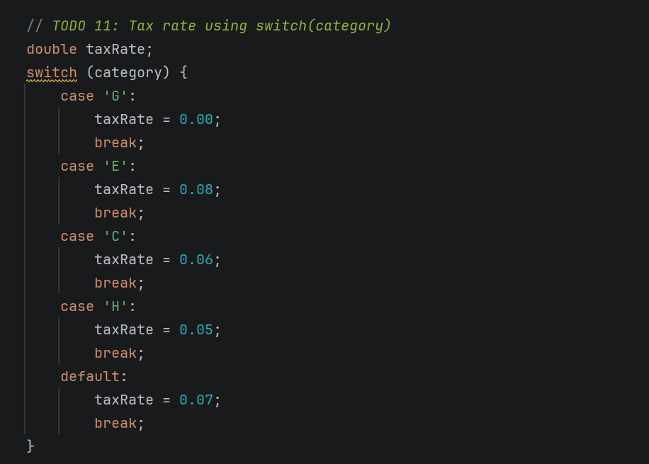
Figure 4. Switch statement for category-based tax rates (TODO 11).
Why Relying on a Single Rule Can Be Misleading
The risk flag (TODO 12) demonstrates the danger of single-metric evaluation. The rule combines three independent conditions using OR, with AND used within two of them:
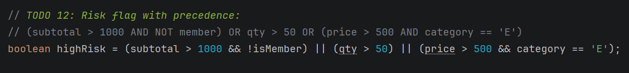
Figure 5. Risk flag using compound OR/AND/NOT and conditional operator (TODOs 12–13).

Using subtotal alone would incorrectly flag large orders from loyal members. Using quantity alone would miss expensive single-unit fraud. The three-condition OR rule encodes domain knowledge: value, volume, and category risk are all independent signals that must be considered together for fair and accurate flagging.
Connections to Evaluation Mindsets and Bias–Variance Tradeoff
Mitchell (1997) describes the bias–variance tradeoff as the tension between underfitting (high bias, simple model) and overfitting (high variance, overly complex model). This maps directly to the discount and risk rules. A single-rule system—flagging every order over $500 as high risk—is high-bias: simple and consistent, but frequently wrong. The compound three-condition rule is lower bias but more sensitive to input edge cases. Likewise, a flat discount for everyone is high-bias; the tiered system with member bonuses is more expressive but requires careful testing to ensure rule interactions produce intended outcomes.
Operator-Precedence Bug: Identification and Fix
During implementation, the initial risk flag draft omitted explicit parentheses. While Java’s precedence (&& binds tighter than ||) produced the same result in this case, the missing parentheses created a serious maintenance risk. The bug was identified by inserting System.out.println() statements to trace sub-expression values across test cases.
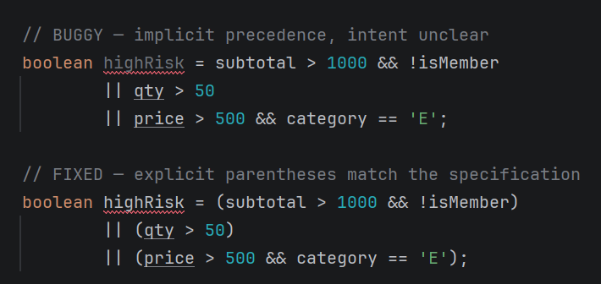
Figure 6. Before and after fix for operator-precedence clarity.

The fix enforces the principle that code communicates intent to human readers as much as instructions to a compiler. Explicit grouping eliminates ambiguity regardless of precedence rules.
Reflection and Improvement Recommendations
The key insight from this activity is that multi-condition logic requires both correctness and clarity. The Scanner.nextLine() buffer issue—where the newline left by nextDouble() was consumed silently, skipping the coupon input—illustrated that Java’s input system requires awareness of buffer state across method calls. Reliability could be improved through unit testing each decision branch with JUnit, extracting discount and tax logic into dedicated methods, replacing the switch with a HashMap<Character, Double> for dynamic rate updates, and defining named constants (e.g., MEMBER_BONUS = 0.05) instead of embedding magic numbers. These steps reduce both the bias (overly simple rules) and variance (fragile edge-case handling) of the system, yielding a more maintainable and reliable program.

References
Mitchell, T. M. (1997). Machine learning. McGraw-Hill.
Oracle. (2023). Java SE documentation: Operators. https://docs.oracle.com/javase/tutorial/java/nutsandbolts/operators.html

